Software Requirements

Specification

**for**

**E-LEARNING APPLICATION MANAGEMENT**

**Version 1.0 approved**

**Prepared by Pritika Kannapiran**

**VIT Chennai**

**17/01/2024**

Copyright © 1999 by Karl E. Wiegers. Permission is granted to use, modify, and distribute this document

**Table of Contents**

**Table of Contents** **2**

**Revision History** **2**

1. **Introduction** Error! Bookmark not defined.
   1. Purpose **Error! Bookmark not defined.**
   2. Document Conventions **Error! Bookmark not defined.**
   3. Intended Audience and Reading Suggestions **Error! Bookmark not defined.**
   4. Product Scope **Error! Bookmark not defined.**
   5. References **Error! Bookmark not defined.**
2. **Overall Description** Error! Bookmark not defined.
   1. Product Perspective **Error! Bookmark not defined.**
   2. Product Functions **Error! Bookmark not defined.**
   3. User Classes and Characteristics **Error! Bookmark not defined.**
   4. Operating Environment **Error! Bookmark not defined.**
   5. Design and Implementation Constraints **Error! Bookmark not defined.**
   6. User Documentation **Error! Bookmark not defined.**
   7. Assumptions and Dependencies **Error! Bookmark not defined.**
3. **External Interface Requirements** Error! Bookmark not defined.
   1. User Interfaces **Error! Bookmark not defined.**
   2. Hardware Interfaces **Error! Bookmark not defined.**
   3. Software Interfaces **Error! Bookmark not defined.**
   4. Communications Interfaces **Error! Bookmark not defined.**
4. **System Features** Error! Bookmark not defined.
   1. System Feature 1 **Error! Bookmark not defined.**
   2. System Feature 2 (and so on) **Error! Bookmark not defined.**
5. **Other Nonfunctional Requirements** Error! Bookmark not defined.
   1. Performance Requirements **Error! Bookmark not defined.**
   2. Safety Requirements **Error! Bookmark not defined.**
   3. Security Requirements **Error! Bookmark not defined.**
   4. Software Quality Attributes **Error! Bookmark not defined.**
   5. Business Rules **Error! Bookmark not defined.**
6. **Other Requirements** Error! Bookmark not defined.

**Appendix A: Glossary** Error! Bookmark not defined.

**Appendix B: Analysis Models** Error! Bookmark not defined.

**Appendix C: To Be Determined List** Error! Bookmark not defined.

*Revision History*

|  |  |  |  |
| --- | --- | --- | --- |
| **Name** | **Date** | **Reason For Changes** | **Version** |
|  |  |  |  |
|  |  |  |  |

**Software Requirements**

**Front-end:** React, JavaScript, CS

**Back-end:** MongoDB

**Work Breakdown Structure**

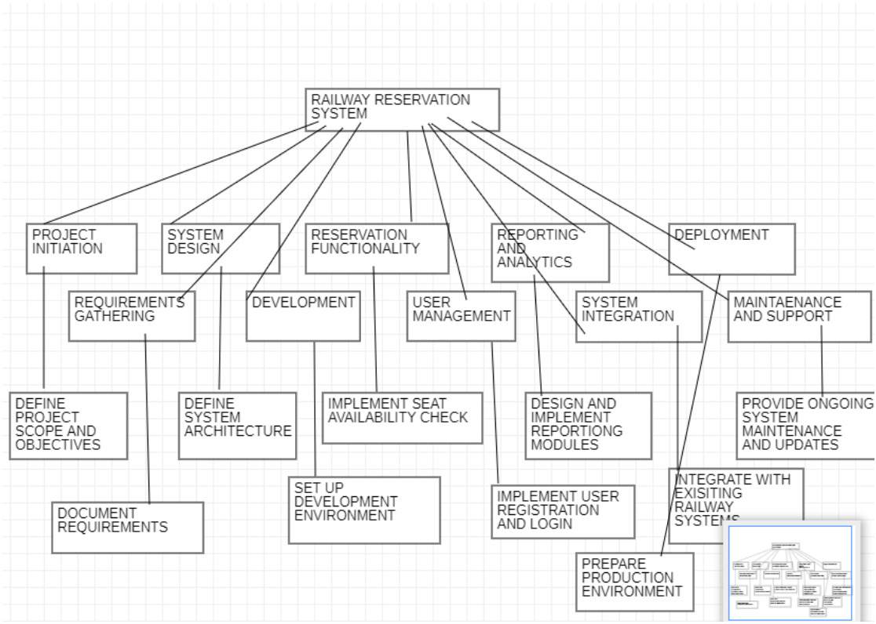

A work breakdown structure (WBS) involves breaking down a project into smaller, more manageable tasks in a hierarchical manner. To illustrate, consider the work breakdown structure designed for a railway reservation system as an example.

Project Initiation

1.1 Define project scope and objectives

1.2 Recognize project stakeholders

1.3 Execute feasibility study

1.4 Specify project deliverables

Requirements Collection

2.1 Identify functional requirements

2.2 Recognize non-functional requirements

2.3 Perform user interviews and workshops

2.4 Document the requirements

System Design

3.1 Define system architecture

3.2 Design the UI (User Interface)

3.3 Design the database schema

3.4 Define data flow and system processes

3.5 Construct system wireframes and prototypes

Development

4.1 Set up development environment

4.2 Implement backend functionality

4.3 Implement frontend functionality

4.4 Integrate the database and conduct data validation

4.5 Implement user authentication and security measures

4.6 Test and debug the system

Reservation Functionality

5.1 Implement seat availability check

5.2 Implement seat selection and reservation

5.3 Integrate the payment gateway

5.4 Generate and dispatch booking confirmation

5.5 Manage reservation cancellations and refunds

User Management

6.1 Implement user registration and login

6.2 Administer user profiles and preferences

6.3 Manage password reset and account activation

6.4 Implement user role-based access control

Reporting and Analytics

7.1 Design and implement reporting modules

7.2 Produce standard reports (e.g., bookings, revenue)

7.3 Implement data analytics features

7.4 Integrate with third-party analytics tools

System Integration

8.1 Integrate with existing railway systems (e.g., ticketing, scheduling)

8.2 Ensure compatibility with other reservation channels (e.g., mobile app, website)

8.3 Execute system integration testing

8.4 Address any integration issues or conflicts

Deployment

9.1 Prepare production environment

9.2 Deploy the system to the production server

9.3 Execute user acceptance testing

9.4 Address any issues or bugs

9.5 Train end-users and provide documentation

Maintenance and Support

10.1 Set up system monitoring and error tracking

10.2 Provide ongoing system maintenance and updates

10.3 Address user feedback and bug reports

10.4 Offer technical support to end-users

**Gantt Chart**

